Car Door Design

Static and dynamic design

ziad | EGFWD | 9/6/2022

# Requirement block diagram

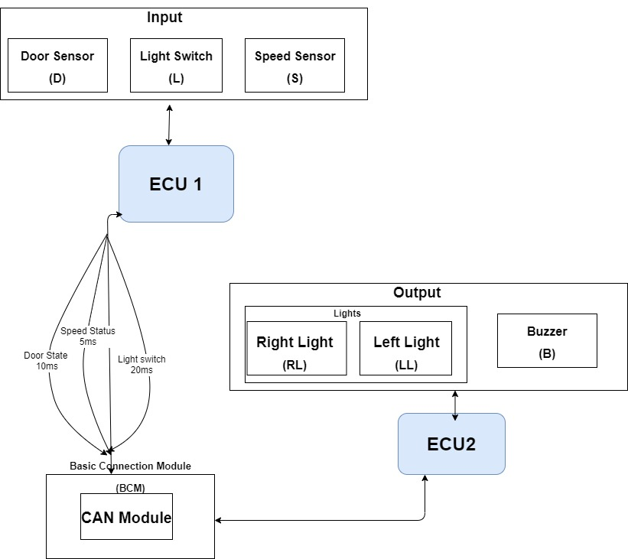

## Static Design

* ECU 1 Layered Architecture Design

* APP Layer
* Basic Communication Module (BCM)

APIs :

* void BCM_initCAN()

Description : initialize CAN module and set its configuration according to CAN config file

* u8 BCM_u8IsReady()

Description : return 1 if can ready else zero

/*gets speed from SMM and save it in the struct*/

* struct SpeedStatusMsg * BCM_setSpeedStatusMsg()

Description : gets speed from Speed Monitor Modeule and save it in the struct of type speed status

* struct DoorStateMsg * BCM_setDoorStateMsg()

Description: gets door status from Door and Light Monitor Module and save it in the struct of type DoorStateMsg

* struct LightSwitchMsg * BCM_setLightSwitchMsg ()

Description : gets lights switch state from Door and Light Monitor Module and save it in the struct of type LightSwitchMsg

* void BCM_updateCANSpeedStatus()

Description: Send speed on CAN bus

* void BCM_updateCANDoorStatus()

Description: Send Door state on CAN bus

* void BCM_updateCANLightSwitchStatus()
* Description: Send Light Switch State on CAN bus

Typedefs: - struct SpeedStatusMsg_t

- struct DoorStateMsg_t

- struct LightSwitchMsg_t

* Speed Monitor Module

APIs :

* void SMM_initSpeedSensor()

Description: Init SpeedSensor according to Speed sensor driver config file

* SENSOR_READING_t SMM_getSensorReading ()

Description: return sensor reading in a 4 byte variable

Typedefs: - uint32 SENSOR_READING_t

* Light Switch Monitor Module

APIs :

* void LSMM_initSwitchMonitor()

Description: Init Light switch sensor according to light switch sensor driver config file

* SWITCH_STATE_t LSMM_getSwitchState()

Description: return switch state either 0 or 1

Typedefs: - enum SWITCH_STATE_t /*0 or 1 */

* Door Monitor Module

APIs :

* void DMM_initDoorMonitor()

Description: Init door sensor according to Door sensor driver config file

* void DMM_getDoorState()

returns either 0 or 1

Typedefs: - Enum DOOR_STATE_t /*0 or 1*/

* OS Layer

APIs :

* void vTask_periodicSendSpeedState()

Description : calls BCM update speed function to send speed reading periodically on CAN bus

* void vTask_periodicSendSwitchState()

Description : calls BCM update switch state function to send switch state periodically on CAN bus

* void vTask_periodicSendDoorState()

Description : calls BCM update door state function to send door state periodically on CAN bus

* void StartSchedular()

Description: enter super loop and start OS scheduling algorithm

* HAL Layer
* Speed Sensor Driver

APIs : -

* void SpeedSensor_init(

SPEED_SENSOR_CHANNEL_t )

Description: init speed senor with the configyrblr pins

Argument :

-SPEED_SENSOR_CHANNEL_t : enum ,Input , Range from 0 to 10 , decription:- specify the ADC cahnnel connected to the sensor

* u32 SpeedSensor_getSensorReading ()

Description: return the speed from the ADC

* CAR_STATE_t SpeedSensor_isCarMoving()

Description: returns either one or zero to indicate if the car is moving

Typedefs: - enum SMM_SENSOR_CHANNEL_t/*from 0 to 10*/

- enum SMM_CAR_STATE_t /*zero or one */

* Light Switch Driver

APIs :

* void LSD_initSwitchMonitor(

LSD_CHANNEL_t,

LSD_PORT_t )

Description: init Switch with the configurble pin that it is connected to

Argument :

- LSD_CHANNEL_t,: enum ,Input , Range from 0 to 7 , decription:- specify the DIO Pin connected to the sensor

- LSD_PORT_t : enum ,Input , Range from 0 to 4 , decription:- specify the DIO Port connected to the sensor

* LIGHT_SWITCH_STATE_t LSD_isSwitchClosed()

Description returns either 0 or 1 to indicate if switch is closed

Typedefs: - enum LSD_CHANNEL_t/*from 0 to 7*/

- enum LSD_PORT_t /*from 0 to 3*/

- enum LSD_LIGHT_SWITCH_STATE_t /*zero or one */

Door Lock Driver

APIs : -

* void DLD_initLockMonitor(

DLD_CHANNEL_t,

DLD_PORT_t )

Description: init Lock sensor with the configurble pin that it is connected to

Argument :

- DLD_CHANNEL_t, enum ,Input , Range from 0 to 7 , decription:- specify the DIO Pin connected to the sensor

- DLD_PORT_t: enum ,Input , Range from 0 to 4 , decription:- specify the DIO Port connected to the sensor

* DOOR_LOCK_STATE_t DLD_isDoorLocked()

Description returns either 0 or 1 to indicate if Door is locked

Typedefs: - enum DLD_CHANNEL_t, /*from 0 to 7*/

- enum DLD_PORT_t/*from 0 to 3*/

- enum DOOR_LOCK_STATE_t /*zero or one*/

* MCAL Layer
* DIO

APIs :

* void DIO_vidInit (PIN_INFO_t)

Description: init DIO with the configuration for every pin

Argument :

- PIN_INFO_t, Array of struct ,Input , Range is defined by a mcro specify the numer of pins used

decription:- specify the DIO Pin configuration like direction Mode Level , PullUP/down etc…

* Void DIO_vidWritePin(PORT , PIN,LEVEL)

Description: write on the pin the rquired value

Argument :

-PORT: enum, input , range from 0 to 4 , deccription: specify the port

- PIN: enum, input , range from 0 to 7 , deccription: specify the pin

-LEVEL: enum, input , range from 0 to 1 , deccription: specify the logical level

* LEVEL DIO_vidReadPin(PORT , PIN)

Description: reads the value of the rquired pin, returns either 0 or 1

Argument :

-PORT: enum, input , range from 0 to 4 , deccription: specify the port

- PIN: enum, input , range from 0 to 7 , deccription: specify the pin

Typedefs: - struct PIN_INFO_t/*PORT,PIN ,MODE , LEVEL*/

- enum PORT/*0 to 3*/

- enum PIN/*0 to 7*/

- enum LEVEL/*one or zero*/

-enum MODE /*one or zero*/

* ADC

APIs :

* void ADC_vidInit (CHANNEL, MODE)

description: init ADC with a specific channel and mode of operation

arguments:

* CHANNEL: enum ,input, range from 0 to 10 ,
* MODE: enum , input , range from 0 to 3 , specify one of the 4 modes of the ADC
* U32 ADC_u32StartConversion()

Description : starts the conversion of ADC

* void ADC_vidEnableInt(CHANNEL)

Description : enable the interrupt of ADC to rad value from ISR

Typedefs: - enum CHANNEL/*0 to 9*/

- enum MODE/*0 to 3*/

* TIMERS

APIs :

* void TIMER_init ( CHANNEL_INFO_t * )

description: init timer with the used channels and their modes of operation

arguments:

* CHANNEL_INFO_t: Array of struct , range is specified by a Macro , input , description contains the configuration of every timer channel /*timer mode timer Interrupt state continuous or one shot */
* Void TIMER_vidStart(u32 ticks)

Description : start timer and put ticks in the counter register

Argument :

* Ticks : 4bytes variable , input , range from 0 to 232 ,specify the numer of ticks to be counted by the timer
* void TIMER_vidStop()

Description : stop timer

* u32 TIMER_u32GetTimeElapsed()

Description : returns the number of ticks counted till now

* u32 TIMER_u32GetTimeRemaining()

Description : returns the number of ticks remaining till counter finishes

Typedefs: -struct CHANNEL_INFO_t/*Timer Mode , Timer Int sate , continuous or one shot*/

* CAN

APIs :

* void CAN_init ( void )

Description : init CAN

* void Can_SetBaudrate(u16 baudRate)

Description: set the buad rate

Arguments: two bytes variable , Range: 0 to 216 Description: the new buad rate buadrate

* void CAN_Write(u16 data)

Description: write on CAN bus the given data

Arguments: data : two bytes variable , Range: 0 to 216 Description: the data to be written on Can bus

* ECU 2 Layered Architecture Design

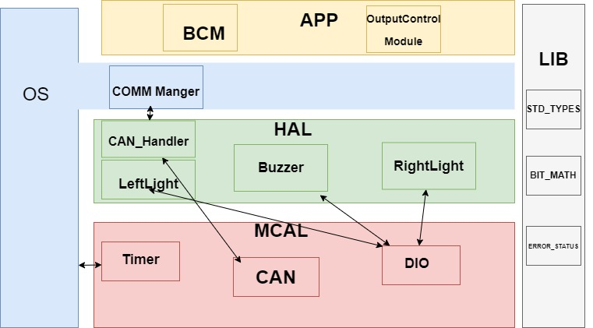

* APP Layer
* Basic Communication Module (BCM)

APIs :

• void BCM_initCAN()

Description : initialize CAN module and set its configuration according to CAN config file

•u8 BCM_u8IsReady()

Description : return 1 if can ready else zero

•struct SpeedStatusMsg * BCM_GETSpeedStatusMsg()

Description : gets speed from CAN bus and pass it to Output Control module by the struct pointer

•struct DoorStateMsg * BCM_setDoorStateMsg()

Description : gets Door state from CAN bus and pass it to Output Control module by the struct pointer

•struct LightSwitchMsg * BCM_setLightSwitchMsg ()

Description : gets switch state from CAN bus and pass it to Output Control module by the struct pointer

Typedefs: - struct SpeedStatusMsg_t

- struct DoorStateMsg_t

- struct LightSwitchMsg_t

* Output Control Module

APIs :

* void OCM_init()

description: init all hard ware modules

* void OCM_update()

description called periodically from OS to perform the control logic according to the new states /*perform the state machine diagram*/

* void OCM_enableLight()

description : enable lights by calling Light driver

* void OCM_disableLight()

description : disable lights by calling Light driver

* void OCM_asynchLightOff()

description: disable light after 3 seconds

* void OCM_enableBuzzer()

description : enable buzzer by calling buzzer driver

* void OCM_disableBuzzer()
* description : disable buzzer by calling buzzer driver

* OS Layer

APIs :

* void vTask_periodicSendSpeedState()

Description : calls BCM get speed function to read speed reading periodically from CAN bus

* void vTask_periodicSendSwitchState()

Description : calls BCM get switch state function to read switch state periodically from CAN bus

* void vTask_periodicSendDoorState()

Description : calls BCM get door state function to read door state periodically from CAN bus

* void vTask_peridocOutputLogicControl()

description calls update function from Output control module to perform state machine

* void StartSchedular()

Description: enter super loop and start OS scheduling algorithm

* HAL Layer
* Light Driver

APIs :

* void LD_LeftLightInit(

LD_CHANNEL_t,

LD_PORT_t)

Description: init left light with the configurble pin that it is connected to

Argument :

- LD_CHANNEL_t,: enum ,Input , Range from 0 to 7 , decription:- specify the DIO Pin connected to the sensor

- LD_PORT_t : enum ,Input , Range from 0 to 4 , decription:- specify the DIO Port connected to the sensor

* -void LD_RightLightInit(

LD_CHANNEL_t,

LD_PORT_t)

Description: init right light with the configurble pin that it is connected to

Argument :

- LD_CHANNEL_t,: enum ,Input , Range from 0 to 7 , decription:- specify the DIO Pin connected to the sensor

- LD_PORT_t : enum ,Input , Range from 0 to 4 , decription:- specify the DIO Port connected to the sensor

* void LD_enableLiftlight()

description: enable left light by calling write pin func in DIO

* void LD_disnableLiftlight()

description: disable left light by calling write pin func in DIO

* void LD_enableRightlight()

description: enable right light by calling write pin func in DIO

* void LD_disableRightlight()
* description: disable right light by calling write pin func in DIO

Typedefs: - enum LD_CHANNEL_t/*from 0 to 7*/

- enum LD_PORT_t/*from 0 to 3*/

- enum SMM_CAR_STATE_t/*zero or one*/

* Buzzer Driver

APIs :

* void BD_initBuzzer( BD_CHANNEL_t,

BD_PORT_t )

Description: init buzzer with the configurble pin that it is connected to

Argument :

-BD_CHANNEL_t,: enum ,Input , Range from 0 to 7 , decription:- specify the DIO Pin connected to the sensor

-BD_PORT_t: enum ,Input , Range from 0 to 4 , decription:- specify the DIO Port connected to the sensor

* Void BD_enableBuzzer()

Description : enable buzzer by calling DIO

* Void BD_disableBuzzer

Description : disable buzzer by calling DIO

Typedefs: - enum BD_CHANNEL_t/*from 0 to 7*/

- enum BD_PORT_t/*from 0 to 3*/

* MCAL Layer
* DIO

APIs :

* void DIO_vidInit (PIN_INFO_t)

Description: init DIO with the configuration for every pin

Argument :

- PIN_INFO_t, Array of struct ,Input , Range is defined by a mcro specify the numer of pins used

decription:- specify the DIO Pin configuration like direction Mode Level , PullUP/down etc…

* Void DIO_vidWritePin(PORT , PIN,LEVEL)

Description: write on the pin the rquired value

Argument :

-PORT: enum, input , range from 0 to 4 , deccription: specify the port

- PIN: enum, input , range from 0 to 7 , deccription: specify the pin

-LEVEL: enum, input , range from 0 to 1 , deccription: specify the logical level

* LEVEL DIO_vidReadPin(PORT , PIN)

Description: reads the value of the rquired pin, returns either 0 or 1

Argument :

-PORT: enum, input , range from 0 to 4 , deccription: specify the port

- PIN: enum, input , range from 0 to 7 , deccription: specify the pin

Typedefs: - struct PIN_INFO_t/*PORT,PIN ,MODE , LEVEL*/

- enum PORT/*0 to 3*/

- enum PIN/*0 to 7*/

- enum LEVEL/*one or zero*/

-enum MODE /*one or zero*/

* TIMERS

APIs :

* void TIMER_init ( CHANNEL_INFO_t * )

description: init timer with the used channels and their modes of operation

arguments:

* CHANNEL_INFO_t: Array of struct , range is specified by a Macro , input , description contains the configuration of every timer channel /*timer mode timer Interrupt state continuous or one shot */
* Void TIMER_vidStart(u32 ticks)

Description : start timer and put ticks in the counter register

Argument :

* Ticks : 4bytes variable , input , range from 0 to 232 ,specify the numer of ticks to be counted by the timer
* void TIMER_vidStop()

Description : stop timer

* u32 TIMER_u32GetTimeElapsed()

Description : returns the number of ticks counted till now

* u32 TIMER_u32GetTimeRemaining()

Description : returns the number of ticks remaining till counter finishes

Typedefs: -struct CHANNEL_INFO_t/*Timer Mode , Timer Int sate , continuous or one shot*/

* CAN

APIs :

* void CAN_init ( void )

Description : init CAN

* void Can_SetBaudrate(u16 baudRate)

Description: set the buad rate

Arguments: two bytes variable , Range: 0 to 216 Description: the new buad rate buadrate

* u16 CAN_Read(void)

Description: read from CAN bus the data , returns a 2 bytes variable

## Dynamic Design

* ECU 1

State Machine Diagram

Sequence Diagram

* ECU 2

State Machine Diagram

Sequence Diagram

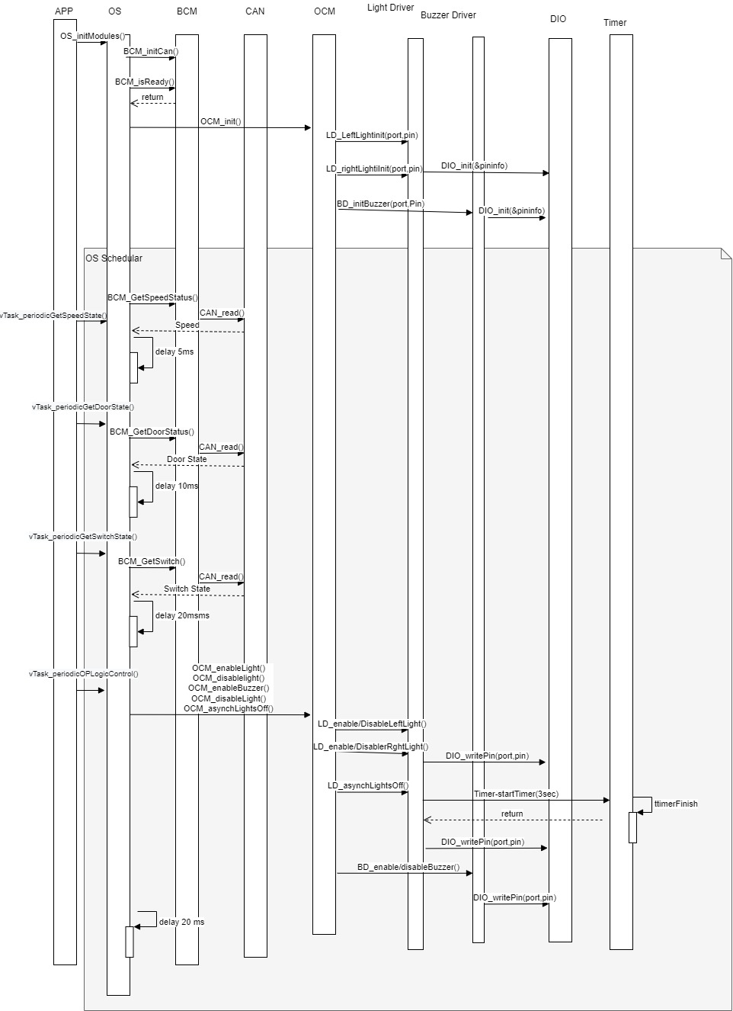

File Structure digram 